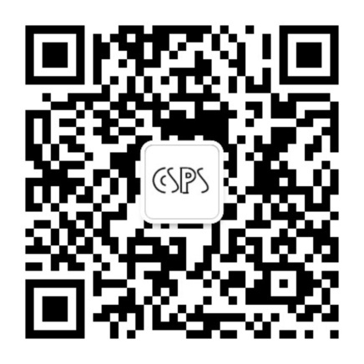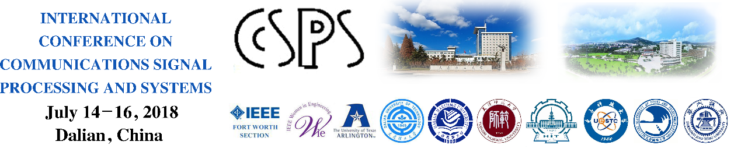

**Call For Paper**

**The 7th International Conference on Communications, Signal Processing, and Systems (CSPS)**

（第七届通信、信号处理和系统（CSPS 2018）的国际会议）

第七届通信、信号处理和系统（CSPS 2018） 国际会议开始征稿。本会议由2012年开始，每年举办一届，在前六界会议中，论文集共发表了近2000篇学术论文，其中有280多篇扩充后投稿并发表到SCI期刊中。本次会议欢迎您的投稿，更多信息请扫描会议二维码或关注会议网站：http://[www.cspstjnu.com](http://www.cspstjnu.com)

**July 14-16 2018, Dalian, China**

**Sponsored by:**

**IEEE Fort Worth Section, USA**

**IEEE Women in Engineering of Harbin Section, China**

**University of Texas at Arlington, USA**

**Dalian University of Technology, China**

**Dalian Maritime University, China**

**Tianjin Normal University, China**

**Harbin Institute of Technology, China**

**University of Electronic Science and Technology, China**

**Beijing University of Posts and Telecommunications, China**

**Shanghai Jiaotong University, China**

The7th International Conference on Communications, Signal Processing, and Systems (CSPS) will be held in July 2018 in Dalian, China. Prospective authors are invited to submit original technical papers for oral or poster presentations at CSPS and publication in the Conference Proceedings. The papers in communications, signal processing, and systems are solicited in the following topics, but are not limited to:

* Wireless communications
* Wireless networks
* Optical communications and networks
* Internet of Things
* Wireless sensor networks
* Wireless mesh networks
* Ad hoc networks
* Underwater sensor networks
* Network security
* Testbed of communications and networks
* Information theory and coding
* Multimedia communications
* Smart grid
* **Radar signal processing**
* Audio and acoustic signal processing
* Bio imaging and signal processing
* Design and implementation of signal processing systems
* Image, video and multidimensional signal processing
* Industry technology tracks
* Information forensics and security
* Machine learning for signal processing
* Multimedia signal processing
* Sensor array and multichannel signal processing
* Signal processing education
* Signal processing for communications and networking
* Signal processing theory and methods
* Speech processing
* Spoken language processing
* Analog Signal Processing
* Genomics Signal Processing
* Biomedical and Life-Science Circuits, Systems and Applications
* Circuits and Systems for Communications
* Computer-Aided Network Design
* Digital Signal Processing
* Education in Circuits and Systems
* Live Demonstrations of Circuits and Systems
* Multimedia Systems and Applications
* Nanoelectronics and Gigascale Systems
* Neural Networks and Systems
* Fuzzy Logic Systems
* Nonlinear Circuits and Systems
* Power and Energy Circuits and Systems
* Sensory Systems
* Radar Systems
* Chaos Systems
* Visual Signal Processing and Communications
* VLSI Systems and Applications
* Satellite and Space Communications

All accepted papers will be published in Lecture Notes in Electrical Engineering, a book series published by Springer, and is indexed by EI-indexed, ISI Proceedings, SCOPUS, MetaPress, Springerlink.

The 1st, 2nd, 3rd, 4th, 5th and 6th International Conference on Communications, Signal Processing, and Systems (CSPS) were held in Beijing in October 2012, in Tianjin in September 2013, in Hohhot in July 2014, in Chengdu in October 2015, in Chongqing in October 2016, in Harbin in July 2017 respectively. In the previous six conferences, more than 280 papers (after further extension) were selected into the following 10 SCI journals.

•EURASIP Journal on Wireless Communications and Networking

•Wiley Security and Communication Networks (SCN) Journal

•International Journal of Sensor Networks

•EURASIP Journal on Advances in Signal Processing

•(Elsevier) Physical Communications

•(Elsevier) Signal Processing

•(Elsevier) Ad Hoc Networks

•(Elsevier) Pattern Recognition

•Mobile Information Systems

•International Journal of Distributed Sensor Networks

It is expected that similar number of papers will be selected into SCI journals in 2018 CSPS conference.

**Submission:**

All submissions should be written in English with a maximum paper length of eight (8) printed pages including figures without incurring additional page charges.

Standard Springer book templates are available for both LaTeX and Microsoft Word format.

Please be aware that Springer book template size is much smaller than that of IEEE template (almost half size).

Only PDF files will be accepted for the review process and all submissions must be done through EDAS.

Authors can use the link below for submission:

<https://easychair.org/conferences/?conf=csps2018>

**Important Dates:**

**Paper Submission Deadline: April 20th, 2018**

**Acceptance Notification: June 15th, 2018**

**Camera Ready Paper: July 1st, 2018**

**General Co-Chairs:**

Hongyu Wang, Dalian University of Technology, China

Liyan Meng, Dalian Maritime University, China

Tariq S. Durrani, University of Strathclyde, UK

Qilian Liang, University of Texas at Arlington, USA

Yiming Pi, University of Electronic Science and Technology, China

Baoju Zhang, Tianjin Normal University, China

**TPC Co-Chairs:**

Xin Liu, Dalian University of Technology, China

Wei Wang, Tianjin Normal University, China

Min Jia, Harbin Institute of Technology, China

Zhenyu Na, Dalian Maritime University, China

Jing Liang, University of Electronic Science and Technology, China

Jiasong Mu, Tianjin Normal University, China

Xuemai Gu, Harbin Institute of Technology, China

Zan Li, Xidian University, China

Qihui WU, Nanjing University of Aeronautics and Astronautics, China

Shi Jin, Southeast University, China

Mugen Peng, Beijing University of Posts and Telecommunications

Feifei Gao, Tsinghua University, China

Peng Li, Dalian Polytechnic University, China

**International Advisory Committee:**

Tieniu Tan, Chinese Academy of Science, China

Victor C.M. Leung,University of British Columbia, Canada

Kat-Kit Wong, University College London, UK

Gene Frantz, Texas Instruments, USA

ErMeng Hwa, Nanyang Technological University, Singapore

ZhishengNiu, Tsinghua University, China

Qing Guo, Harbin Institute of Technology, China

Wan-Chi Siu, Hong Kong Polytechnic University, Hong Kong

Arumugam Nallanathan, King’s College London, UK

Yan Zhang, [University of Oslo, Norway](http://www.baidu.com/link?url=Dsvp6etR3Vg8Z4y7HPpOyNFCb-_STenCsipW4mxqtxQ1O2UDOGfbSrLf5Poh5Ygt)

F. Richard Yu, Carleton University, Canada

Yunfei Chen, University of Warwick, UK

Hongjian Sun,Durham University, UK

Wei Xu, Southeast University, China

**Publication Co-Chairs:**

Yue Wang, Tianjin Normal University, China

YulongZou, Nanjing University of Posts and Telecommunications, China

Hui Li, Hainan University, China

Guoru Ding, Southeast University, China

Xiaoming Chen, Zhejiang University, China

Yueling Che, Shenzhen University, China

Su Hu, University of Electronic Science and Technology of China, China

Xinlin Huang, Tongji University, China

Yun Lin, Harbin University of Engineering, China

Jie Tang, South China University of Technology, China

Chungang Yang, Xidian University, China

Feng Shu, Nanjing University of Science and Technology, China

Qinghe Du, Xi'an Jiaotong University, China

Wei Wang, Zhejiang University, China

**Publicity Co-Chair:**

Guan Gui, Nanjing University of Posts and Telecommunications, China

Liang Xiao, Xiamen University, China

Xiaopeng Yang, Beijing Institute of Technology, China

Gongliang Liu, Harbin Institute of Technology (Weihai), China

Haijun Zhang, University of Science & Technology Beijing, China

Qingquan Sun, California State University San Bernardino, USA

Xiaofei Zhang, Nanjing University of Aeronautics and Astronautics, China

Zilong Liu, Nanyang Technological University, Singapore

Yuan Zhou, Tianjin University, China

Yong Li, Tsinghua University, China

Jingjiang Wang, Qingdao University of Science and Technology, China

Ning Wang, Zhengzhou University, China

YunjianJia, Chongqing University, China

Qingjiang Shi, Nanjing University of Aeronautics and Astronautics, China

**Keynote Co-Chairs**

Jean X. Gao, University of Texas at Arlington, USA

Shenghong Li, Shanghai Jiaotong University, China

Haibo Zhou, Naijing University, China

Lei Chen, Georgia Southern University, USA

Weijie Xia, Nanjing University of Aeronautics and Astronautics, China

Yong Zeng, National University of Singapore, Singapore

Tingting Zhang, Harbin Institute of Technology (Shenzhen), China

Jun Li, Nanjing University of Science and Technology, China

Jingyu Hua, Zhejiang University of Technology, China

Weigang Chen, Tianjin University, China

Rong Chai, Chongqing University of Posts and Telecommunications

Lusheng Wang, HeFei University of Technology, China

Yanjing Sun, China University of Mining and Technology, China

Rongfei Fan, Beijing Institute of Technology, China

**Local Arrangement Co-Chairs:**

Minglu Jin, Dalian University of Technology, China

Nan Zhao, Dalian University of Technology, China

Xufen Xie, Dalian Polytechnic University, China

Jie wang, Dalian University of Technology, China

Hui Li, Dalian University of Technology, China

**Registration & Financial Co-Chairs:**

Liang Han, Tianjin Normal University, China

Yi Sun, Dalian University of Technology, China

Yanqing Guo, Dalian University of Technology, China

Ming Li, Dalian University of Technology, China

Bo Wang, Dalian University of Technology, China